

HR MANAGEMENT SYSTEM

submitted in partial fulfillment of the requirement of

BACHELOR

IN

COMPUTER ENGINEERING

BY

Armaan Nakhuda 02

Sushant Navle 05

Samay Pandey 09

Peeyush Karnik 57

Supervisor

Vedika Patil



Department Of Computer Engineering

K.C. College of Engineering and Management Studies and Research

Mith Bunder Road, Kopri, thane (E) - 400603

University of Mumbai (AY 2023-24)

CERTIFICATE

This is certify that the mini project entitled “HR MANAGEMENT SYSTEM’’ is Bonafede work of Armaan Nakhuda (B-02); Sushant Navle (B-05); Samay Pandey (B-09); Peeyush Karnik (B-57) submitted to the University of Mumbai in partial fulfillment of the requirement for the award of the degree of “Bachelor of Engineering in Computer Engineering”.

Supervisor

Prof. Vedika Patil

Head of Department Principal

Prof. Mahesh Maurya Dr. Vilas Nitnavare

Mini Project Approval

This mini project entitled HR MANAGEMENT SYSTEM by Armaan Nakhuda (B-02); Sushant Navle (B-05); Samay Pandey (B-09); Peeyush Karnik (B-57)is approved for the degree of Bachelor of engineering in Computer Engineering.

Examiners

1..............................................................................

(Internal Examiner Name & sign)

2.....................................................................

(External Examiner name & sign)

Date: -

Place: -

Contents

Abstract

Acknowledgement

List of abbreviations

List of figures

1. Introduction

1.1 Introduction

1.2 Motivation

1.3 Problem Statement & Objectives

2 . mini project contribution

3 . Proposed System

3.1 Introduction

3.2 Architecture or Framework

3.3 Details of hardware and software

3.4 Experiment and Results

3.5 Conclusion and future work

4 . References

1

List Of Figure

|  |  |  |
| --- | --- | --- |
| Figure  no. | Figure Name | Page no. |
| 1. |  |  |
| 2. |  |  |
| 3. |  |  |
| 4. |  |  |
| 5. |  |  |
| 6. |  |  |
| 7. |  |  |

2

Abstract

The HR Management System is a comprehensive software application designed to streamline and enhance human resource management processes within an organization. The system employs a user-friendly graphical interface developed using Python, providing an easy experience for users. Key features include secure user authentication, role-based access control, and a responsive design that adapts to varying screen sizes.

The application integrates Firebase, a cloud-based database service, for secure storage and retrieval of user credentials. This ensures data integrity and allows administrators to manage user access and permissions efficiently. The system caters to different user roles, including administrators, HR personnel, bosses, and employees, each with tailored functionalities.

The login interface serves as the gateway to the system, allowing users to access role-specific modules. The modular design facilitates easy future enhancements. Admins can manage system credentials through Firebase, ensuring a centralized and secure user management system

The HR, employee, and boss modules offer distinct functionalities tailored to the respective roles. These include access to employee records, performance evaluations, and administrative tasks. The system incorporates dynamic resizing of background images, providing a visually appealing and responsive user interface.

The project aims to improve HR management efficiency, reduce manual workloads, and enhance overall organizational productivity. By leveraging modern technologies, the HR Management System contributes to the digital transformation of HR processes, promoting a more streamlined and effective approach to human resource management.­­

3

Acknowledgement

We would like to express our sincere gratitude to all those who contributed to the development and success of this HR MANAGEMENT SYSTEM project.

First and foremost, we extend our appreciation to our team members for their dedication and hard work in designing, programming, and testing the management system. Their collective efforts played a vital role in bringing this project to fruition.

We are also thankful for the guidance and support of our project supervisor Prof. Vedika Patil whose expertise and insights were invaluable throughout the development process. Your mentorship and encouragement significantly enriched our project.

We acknowledge the numerous individuals who provided feedback, participated in beta testing, and contributed to refining the HR Management System. Your input was essential in enhancing the system's overall user experience, and we are grateful for your valuable contributions.

We extend our gratitude to the open-source software community, whose contributions laid the foundation for many tools and libraries incorporated into this project. The collaborative spirit of the community has been a driving force behind the success of the HR Management System.

Finally, we want to express our heartfelt thanks to our friends and family for their unwavering support and understanding during the project's development period. Your encouragement and patience were essential in helping us overcome challenges and stay motivated.

This HR Management System project would not have been possible without the collaborative efforts and support of all these individuals and groups. Thank you for being an integral part of this transformative journey.

4

List Of Abbreviation

List of Abbreviations for HR Management System:

1. HRMS:- Human Resource Management System
2. DBMS:- Database Management System
3. DB:- Database

This list provides a quick reference to the abbreviations used in the HR Management System

5

INTRODUCTION

1.1 Introduction

In the dynamic landscape of modern organizations, the effective management of human resources is paramount to achieving strategic goals and maintaining a competitive edge. The HR Management System (HRMS) emerges as a comprehensive solution, seamlessly integrating technology and human resource management practices to streamline processes, enhance efficiency, and foster a more strategic approach to workforce management.

The HRMS serves as the central hub for all HR-related activities within an organization, providing a robust platform for managing employee information, recruitment, performance appraisal, training, and more. This system not only automates routine HR tasks but also empowers HR professionals with valuable insights through analytics, aiding in informed decision-making.

In this digital age, HR MANAGEMENT SYSTEM With the advent of technology The HRMS consolidates and centralizes employee data, providing a secure and accessible repository for personal details, qualifications, and performance records.

Facilitating employee development, the HRMS aids in planning, implementing, and tracking training programs to enhance skills and knowledge.

As organizations continue to recognize the strategic importance of their human capital, the HRMS emerges as a critical tool in fostering a positive employee experience, ensuring compliance with regulations, and driving organizational success. This introduction sets the stage for exploring the various dimensions and functionalities of the HR Management System, ultimately contributing to the evolution of modern HR practices within the organization.

6

1.2 Motivation for Creating A HR MANAGEMENT SYSTEM

The motivation behind the development of the HR Management System stems from the growing need for organizations to optimize and modernize their human resource management processes. As businesses evolve in today's dynamic environment, efficient HR management becomes crucial for organizational success. Traditional manual methods are often time-consuming, prone to errors, and lack scalability. The HR Management System aims to address these challenges by providing a comprehensive, user-friendly, and technologically advanced solution.

**1. Objectives**

* **Streamlining HR Processes:** The primary objective is to streamline various HR processes, including employee record management, performance evaluation, and administrative tasks. Automation reduces manual efforts, minimizes errors, and accelerates processes.
* **Enhancing User Experience:** The system is designed with a focus on user experience, employing a graphical interface for ease of use. Dynamic resizing of background images ensures a visually appealing and responsive platform, enhancing overall user satisfaction.
* **Role-Based Access Control:** Implementing role-based access control ensures that each user, be it an administrator, HR personnel, boss, or employee, has access only to the functionalities relevant to their role. This enhances security and data privacy.

**2. Technology Stack:**

The use of technologies such as Tkinter for the graphical interface, Pillow for image processing, and Firebase for database management contributes to the system's robustness and scalability. The integration of Firebase ensures secure storage and retrieval of user credentials, aligning with modern cloud-based solutions.

7

1.3 Problem Statements and Objectives

Problem Statements: -

In contemporary organizational environments, traditional human resource management practices often face significant challenges, hindering operational efficiency and limiting the potential for strategic HR contributions. Manual processes, lack of centralized data management, and inadequate automation lead to inefficiencies, errors, and delays in critical HR functions. The absence of a streamlined system compromises data security, inhibits quick decision-making, and impedes the overall effectiveness of HR processes.

1. **Manual and Time-Consuming HR Processes:** Traditional HR management practices heavily rely on manual processes, leading to inefficiencies and delays. Tasks such as employee record management, leave approvals, and performance evaluations are time-consuming and error-prone, hampering the overall productivity of the HR department.
2. **Lack of Centralized Data Management:** Existing HR systems often suffer from fragmented data storage, making it challenging to maintain a centralized and cohesive repository of employee information. This fragmentation results in data redundancies, inconsistencies, and difficulties in extracting meaningful insights for strategic decision-making.
3. **Security Concerns and Unauthorized Access:** Many HR systems lack robust security measures, exposing sensitive employee information to potential breaches. The absence of proper authentication and authorization mechanisms allows unauthorized access to confidential HR data, posing a significant security risk for the organization.
4. **Inadequate Role-Based Access Control:** The absence of role-based access control exacerbates security concerns, as users often have unrestricted access to all system functionalities. This not only compromises data security but also violates the principle of least privilege, hindering the establishment of a secure and compliant HR environment.

8

Objective: -

**1. Streamlining HR Processes:**

* Develop a comprehensive HR Management System that automates and streamlines routine HR processes, such as employee record management, performance evaluations, and administrative tasks.

**2. Enhancing Data Security:**

* Implement robust security measures, including secure user authentication and role-based access control, to ensure the confidentiality and integrity of sensitive employee information.

**3. Improving User Experience:**

* Design a user-friendly graphical interface with dynamic resizing capabilities to enhance the overall user experience, ensuring that the system is accessible and engaging for all users, regardless of their technical proficiency.

**4. Implementing Modern Technologies:**

* Utilize modern technologies such as Tkinter for the graphical interface, Pillow for image processing, and Firebase for database management to create a technologically advanced and scalable HR Management System.

**5. Facilitating Digital Transformation:**

* Contribute to the organization's digital transformation by providing a platform that aligns with modern HR practices, encourages automation, and supports strategic decision-making.

**6. Role-Specific Functionalities:**

* Develop role-specific modules catering to the unique needs of administrators, HR personnel, bosses, and employees, ensuring that each user has access only to functionalities relevant to their role.

**7. Scalability and Future Enhancements:**

* Design the system with a modular architecture to allow for easy scalability and future enhancements, ensuring adaptability to evolving organizational requirements.

9

2.Mini Project Contribution

The workflow was divided and done by all the members of the project group, the work done by each member is as follows:

1. Armaan Nakhuda: Exit and Credits button on login screen

Resizing, centering, and focusing of all windows

Manager Window

50% of Employee window

Documentation- mini project contribution, hardware

and software requirements, experimental result,

Reference

PPT-requirement hardware and software, screenshots

of GUI, references

1. Sushant Navle: Basic login page and admin login screen (no buttons)

Majority of documentation, 50% of code test cases

PPT- introduction to Topic, need of project, problem

statement, literature survey in tabular format, proposed

methodology

1. Samay Pandey: Implementation and connection of DB

Dynamic name on every window

Admin window

HR window

50% of Employee window

Documentation- future scope

PPT-block diagram, flowchart (error correction), detail

design DFD diagram, activity diagram

1. Peeyush Karnik: Documentation-50% of abstract, introduction to problem

statement, flowchart, 50% of code test cases

PPT- algorithm for project development, feasibility

study, flowchart

10

3.Proposed System

3.1 Introduction

Traditional HR practices face challenges in efficiency and security. Our proposed HR Management System introduces automation, centralized data management, and robust security measures. With a user-friendly interface and modern technologies, the system aims to streamline operations, enhance data integrity, and align with organizational digital transformation goals, empowering HR professionals for organizational success.Top of Form

3.2 Architecture

The HR Management System aims to revolutionize HR processes for enhanced efficiency and streamlined operations. This report provides a comprehensive overview of the system architecture.

1. User Interface: -

1. Intuitive design for employee self-service and admin dashboards.
2. Responsive and user-friendly interface.

2. Database Management: -

a. Centralized database for secure storage of employee data.

b. Database management system for efficient data retrieval.

3. Application Logic: -

a. Employee Onboarding: Digital forms and document submission.

b. Attendance Tracking & Performance Records

c. Performance Management: Goal setting, feedback mechanisms.

d. Employee Self-Service: Leave requests and personal information.

4. Technologies Used: -

a. Frontend: Python

b. Database: Firebase

11

Flowchart:-

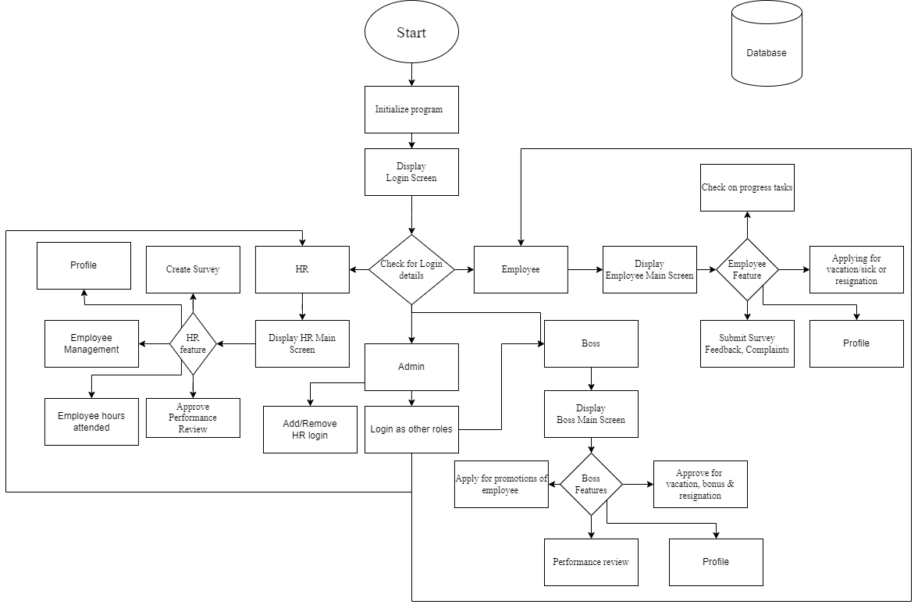

Figure 1

Figure 1 is a flowchart of the basic showcase of HR Management System.

1. Initialization: Login screen helps to identify if the user is Admin, HR, Boss or Employee.
2. Database: The user is then given the features with respect to it’s login details.
3. Features: These are differentiated between Admin, HR, Boss and Employee respectively.
4. Admin: This user can remove or add login details of HR/Manager/Employee and sign in as per what permission level is desired.
5. HR: This user can Add or remove manager/employee, manage salary and approve feedbacks, etc.
6. Boss: This user can View performance, approve for vacation/sick leaves or resignations, bonus or promotions, etc.
7. Employee: This user can check progress, apply for leaves, submit survey or apply for vacations, etc.

12

3.3 Hardware And Software Requirements:-

Hardware :-

1. Minimum Requirements:
2. Processor:- Dual core processor @2.4Ghz
3. Ram:- 4GB Ram
4. Storage:- 2GB free space
5. Internet:- speed: 3mbps
6. Recommended Requirements:
7. Processor:- Quad core processor @2.8Ghz
8. Ram:- 8GB Ram
9. Storage:- 4GB free space
10. Internet: speed: 6mbps

Software :-

1. Minimum Requirements:
2. OS: Windows 10 22H2
3. Python: Version 3.11 with pil, firebase, firebase_admin and tkcalendar modules installed
4. Recommended Requirements:
5. OS: Windows 11 22H2
6. Python: Version 3.12 with pil, firebase, firebase_admin and tkcalendar modules installed

13

3.4 Experimental Result:-

Main login:

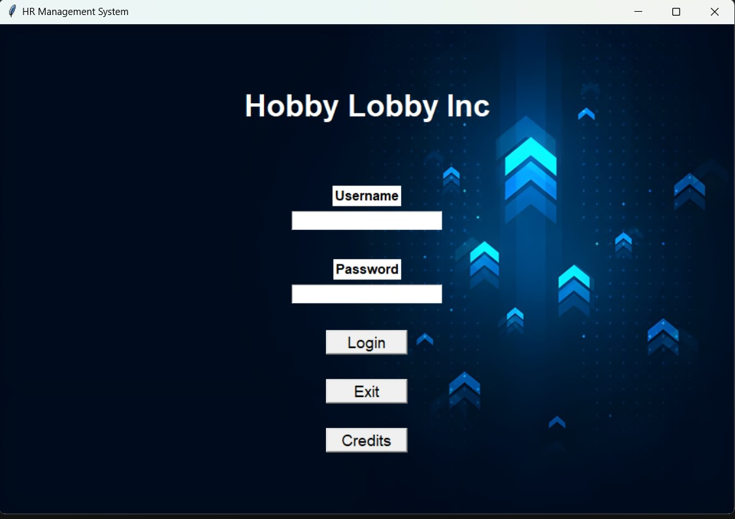

Figure 2

Figure 2: The first page presented to the user upon opening the application, this page gives the input boxes to enter the username and password along with the login button and the exit and credit buttons.

There are 4 types of windows which will open following the user’s login depending on what role has been assigned the user in the DB, the 4 types of logins are Admin, HR, Manager and Employee.

14

Credits Dialog box in main login screen:

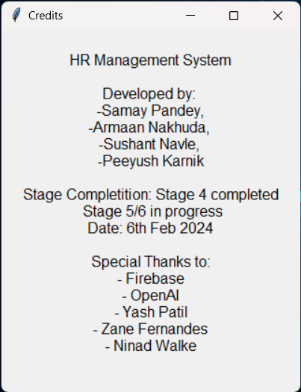

Figure 3

Figure 3- The Credits dialog which opens after clicking the credits button on the main login page.

15

Admin Window:

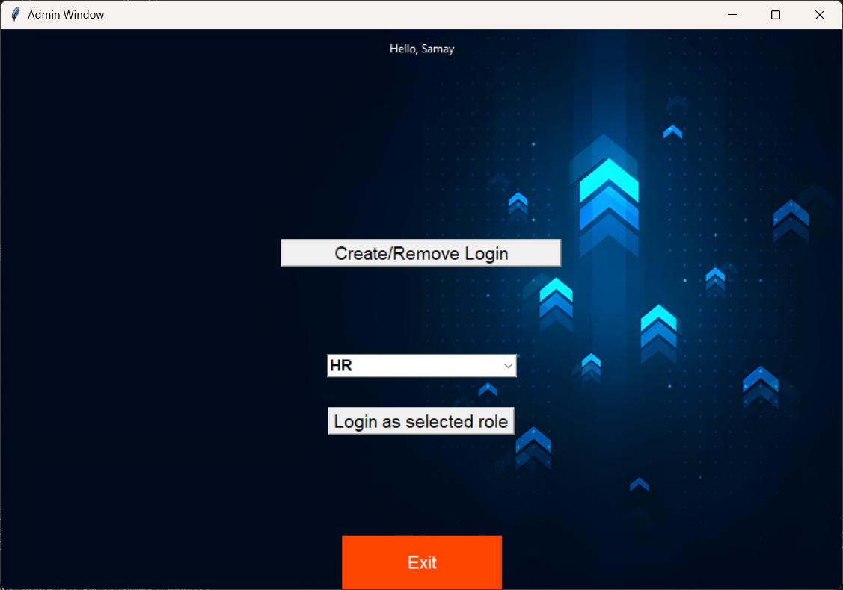

Figure 4

Create/Remove Login: This button will allow the Admin to add or remove logins of HR, Manager or Employee (Figure 5).

Login as Selected Role: The Admin will have an option to simulate as different levels of logins if he/she needs to view or test something as a different permission level.

16

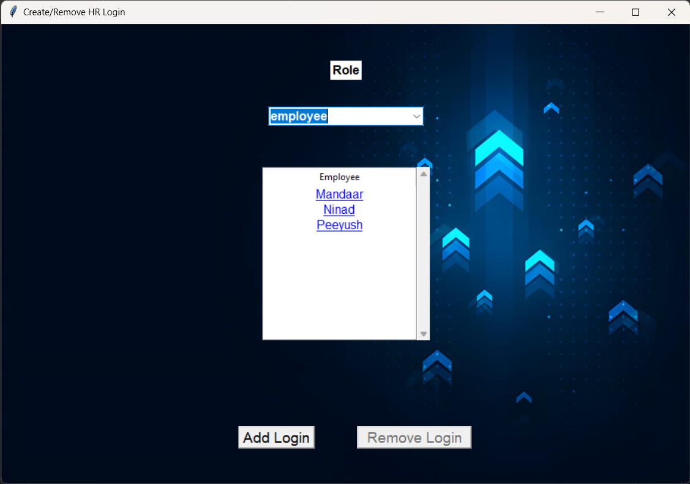

Figure 5

Figure 5- the first screen that is displayed to the user when the Create/Remove button is pressed, this screen gives the Admin the option to select the category of role so the logins of that role are shown, upon it being shown the Admin can select one role and delete it. (Figure 6 and 7).

Clicking the Add login button, opens a new window(Figure 8)

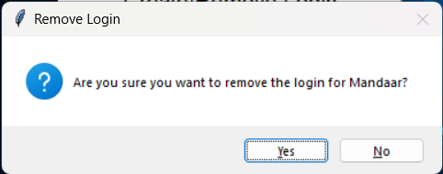 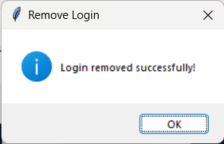

Figure 6 Figure 7

Figure 6 and 7: gives the confirmation and success popups for the removal of the login.

17

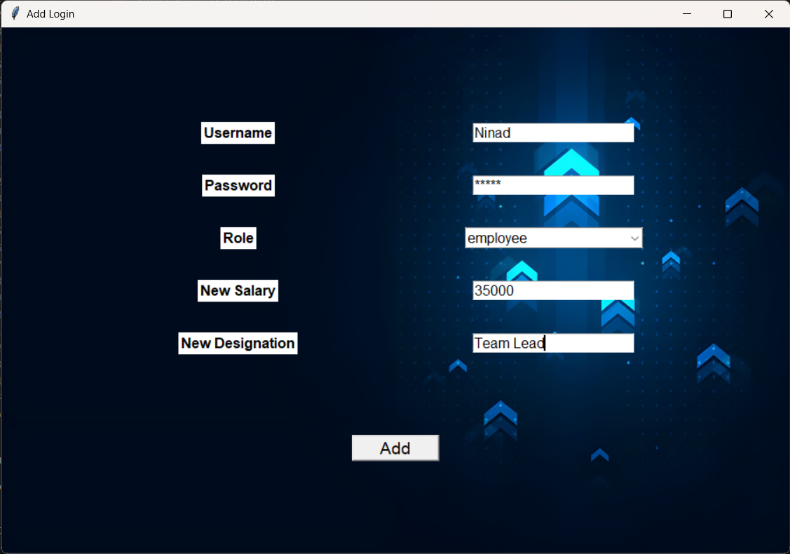

Figure 8

Figure 8- Shows the window to provide details for the new login to be added to the DB.

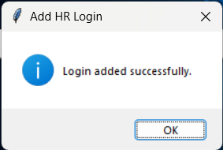

Figure 9

Figure 9: shows the confirmation that the login has been added to the database successfully.

18

HR Window:

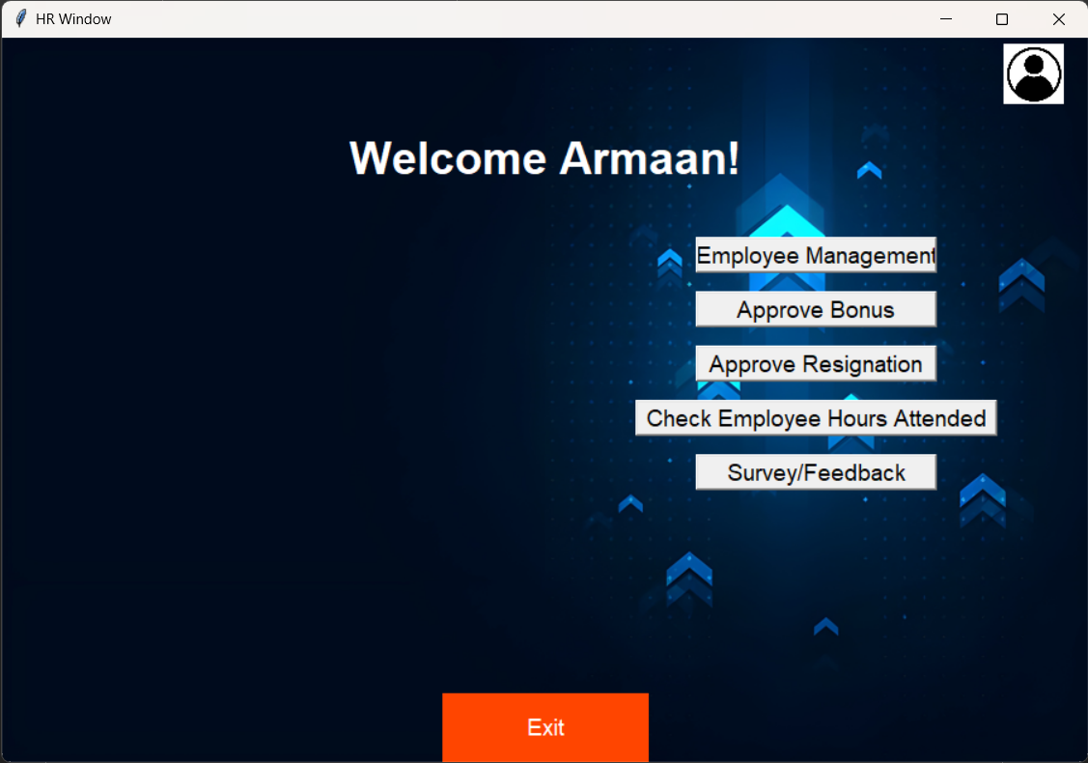

Figure 10

Figure 10: The first screen shown to the HR when the user logins in, it has buttons like employee management (figure 11) to manage Managers and Employees, Approve and assign bonus to employees (figure 18) and Managers (figure 22) respectively, approve resignations for Managers and employees(figure 25) and send out survey with specified questions to the employees to be filled(figure 26).

19

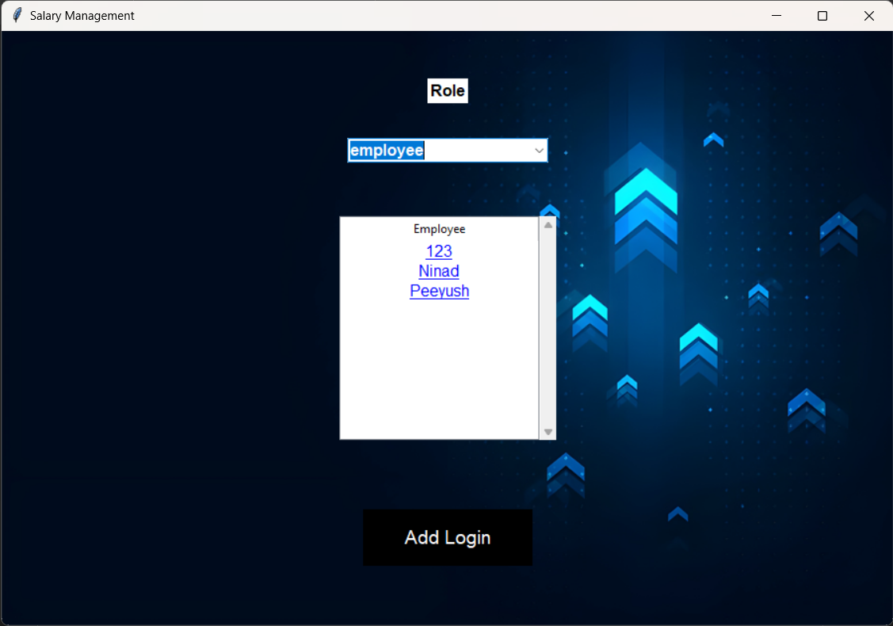

Figure 11

Figure 11: When the Employee Management button is clicked this window will appear to the user which includes a toggle to select the role between manager and employee, upon selecting the role all the logins within that role will show up in the list below, the user can then click on any name to show the details of the employee as shown in figure 12.

The add login button will open a new window which allows to input the details for the new login as shown in figure 8.

20

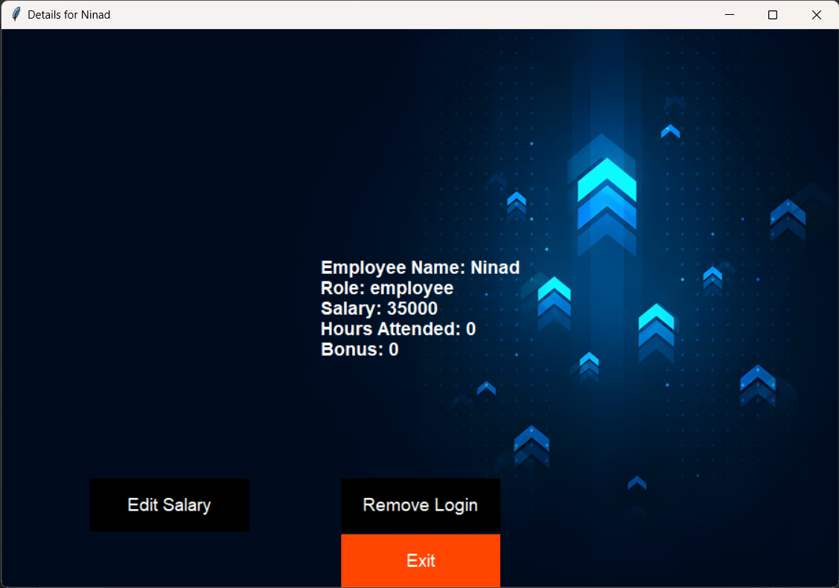

Figure 12

Figure 12: The details of the employee that was clicked is shown in a new window, along with the option to edit the salary(figure 13) and remove the specified login(figure 16) for the employee.

21

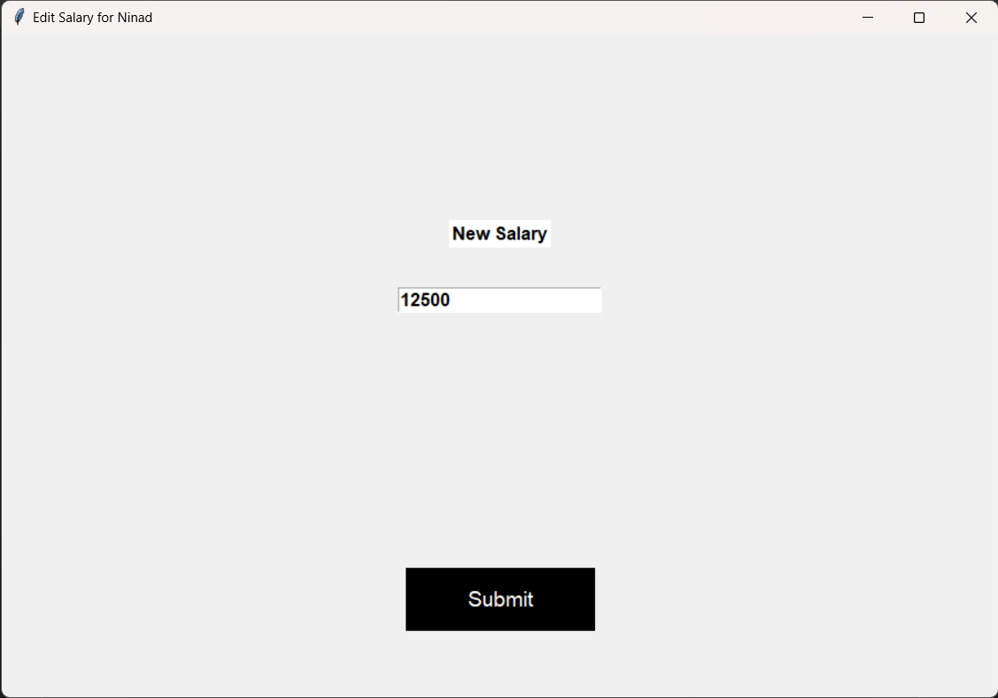

Figure 13

Figure 13: When the user clicks on edit salary button a new window will open asking for the input for the new salary of the Manager/Employee.

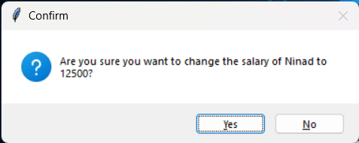

Figure 14

Figure 14: Shows the confirmation asking if the new salary is correct and this new salary should be uploaded the DB.

22

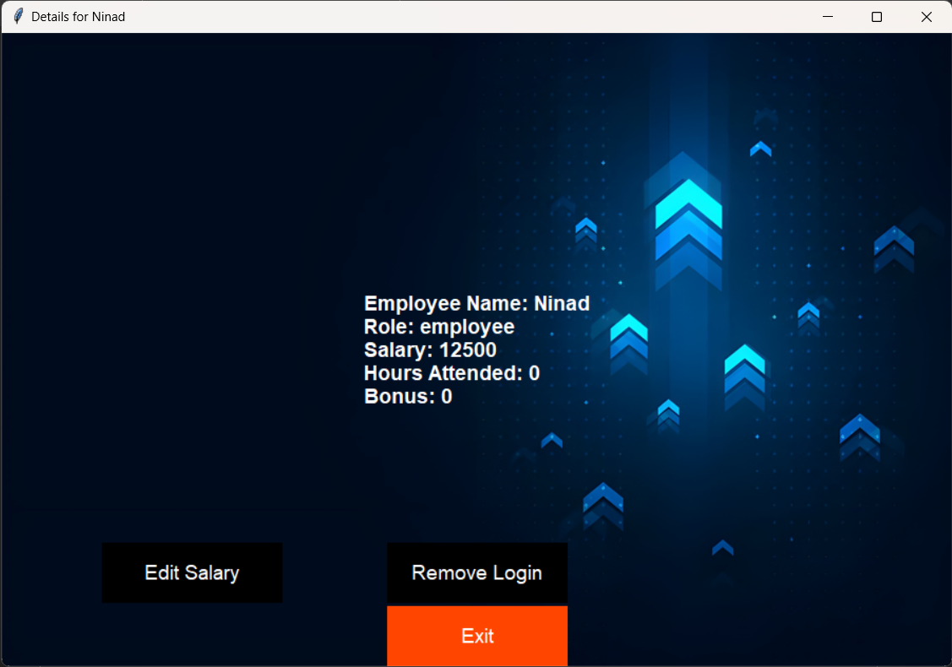

Figure 15

Figure 15: Shows the updated salary in the details window.

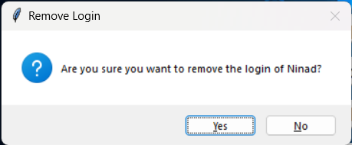 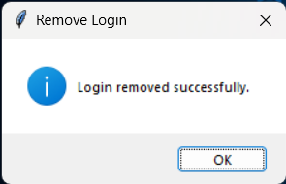

Figure 16 Figure 17

Figure 16 and 17: Shows the Dialog box asking for confirmation and the success dialogs if the HR clicks on yes to delete the login of the user.

23

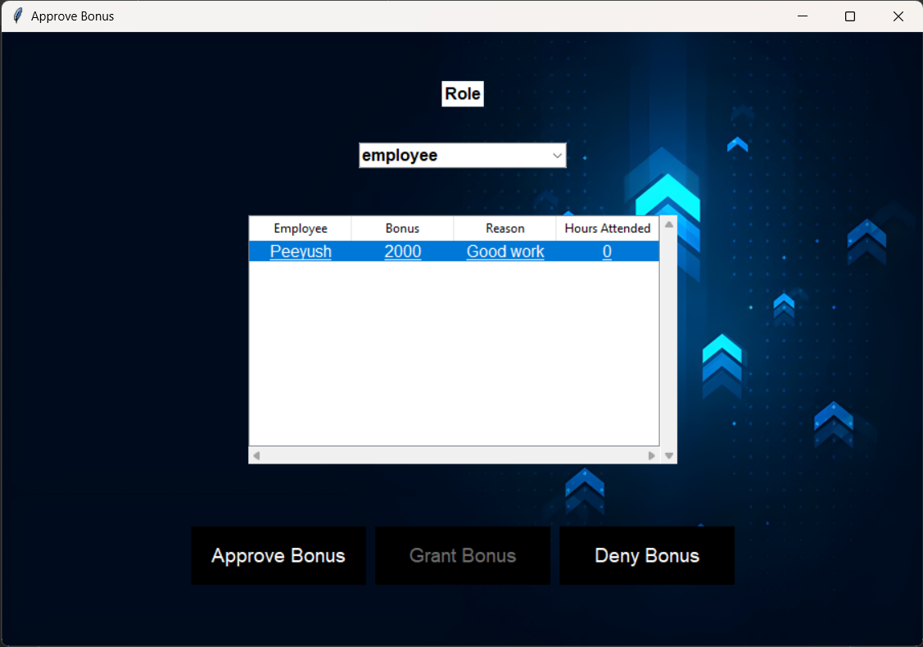

Figure 18

Figure 18: The Employee bonus is requested by the Manager and has to be approved by the HR, giving the HR two options to either approve or deny the request.

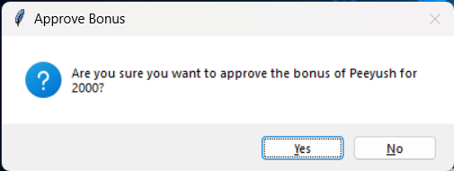 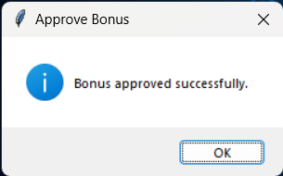

Figure 19 Figure 20

Figure 19: When the approve or deny button is clicked another confirmation is displayed for the respective action.

Figure 20: Shows the dialog box that the action has been completed and the update has been pushed into the DB.

24

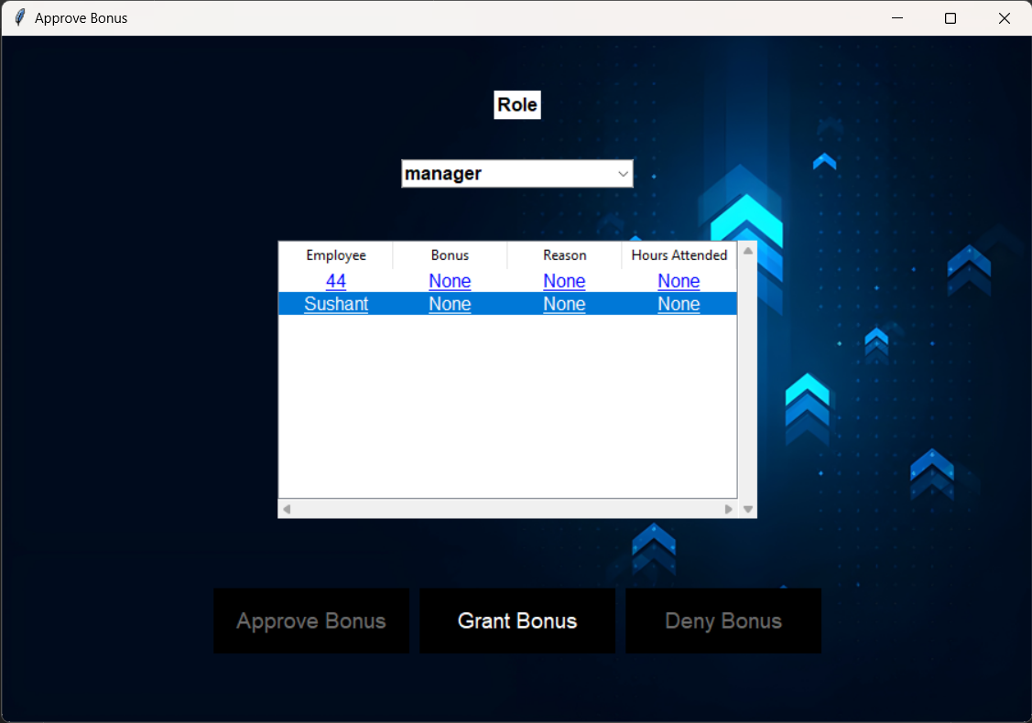

Figure 21

Figure 21: For Manager level the HR directly gives bonus on their discretion, therefore the grant bonus option is available which when clicked opens a new window (figure 22).

25

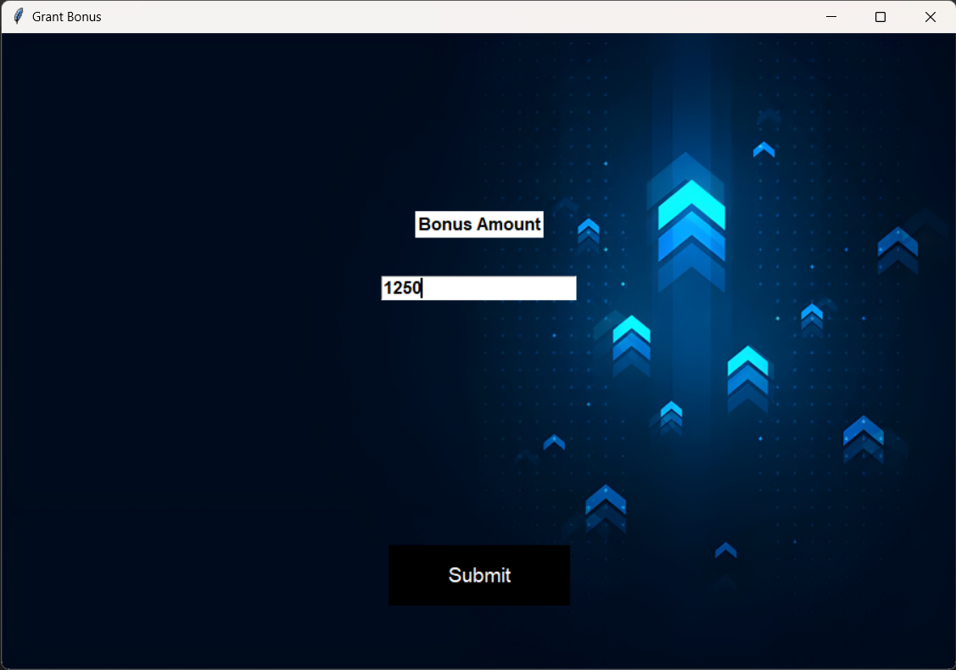

Figure 22

Figure 22: Gives the HR the input box to input the amount of bonus that should be provided the specified Manager, on clicking the submit button (figure 23) is shown.

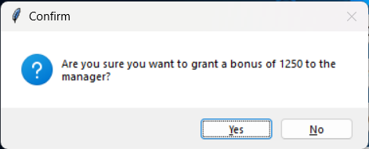 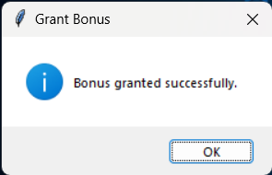

Figure 23 Figure 24

Figure 23 and 24: The confirmation dialog is shown to the user, upon clicking yes the details are updated into the DB and the success dialog is shown.

26

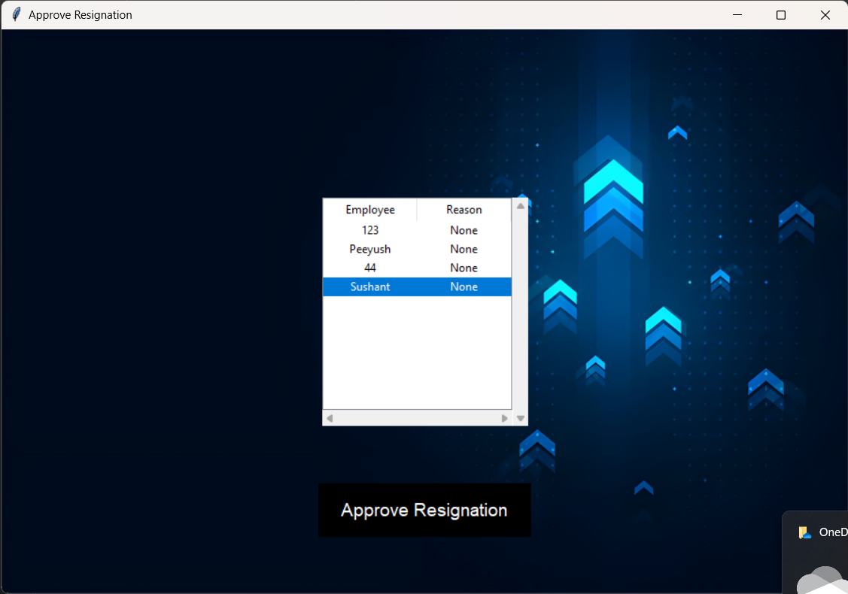

Figure 25

Figure 25: Upon clicking the Approve resignation button a new window shows up with the list of employees whose resignation approval is pending, upon clicking the respective employee the approve button highlights itself which can then be clicked to approve the resignation.

27

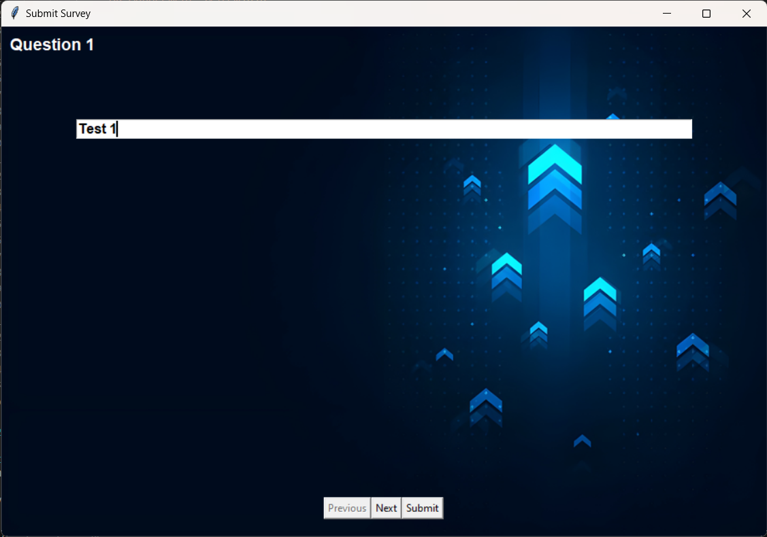

Figure 26

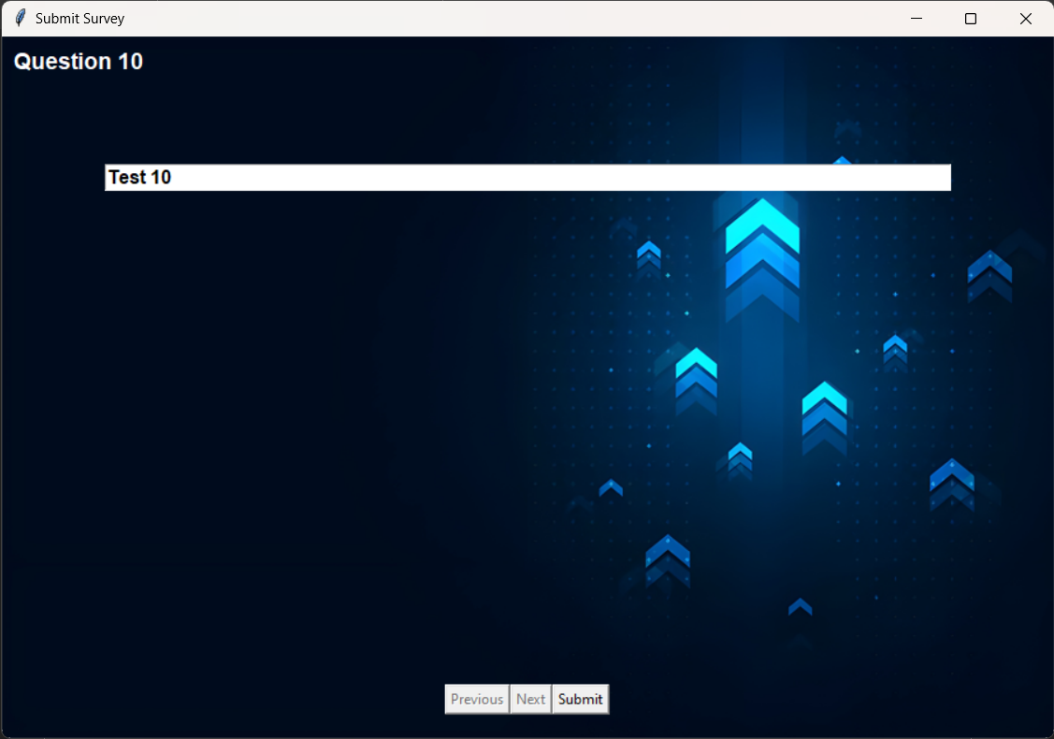

Figure 27

28

Figure 26 and 27: Show the first and last question of the survey along with the previous next and submit buttons to move between the questions and to assign the survey for the employees to fill it.

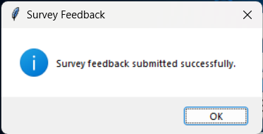

Figure 28

Figure 28: The dialog box that is presented to the user when the submit button is clicked and the new questions have been assigned in the DB.

29

Manager Window:

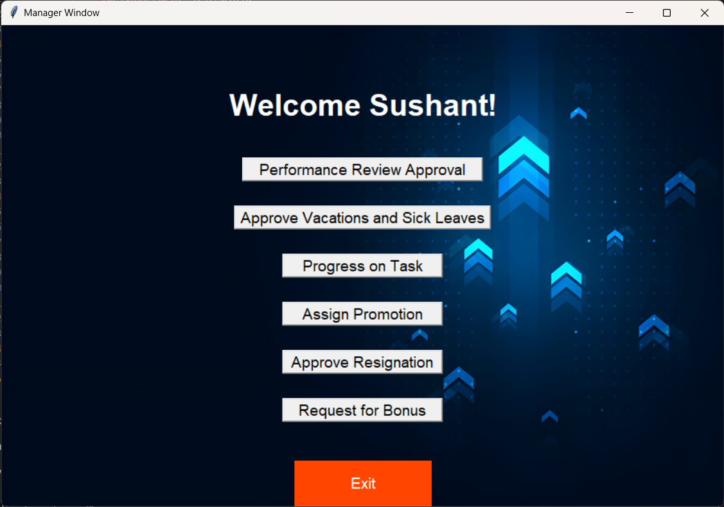

Figure 29

Figure 29: The window that is shown to the user who logs in at the manager level, the user has the options to approve performance reviews (figure 30), approve vacation/sick leaves(figure 32), check progress on tasks which are in progress by employees, assign promotions, approve resignation and request for bonus for employees(figure 37).

30

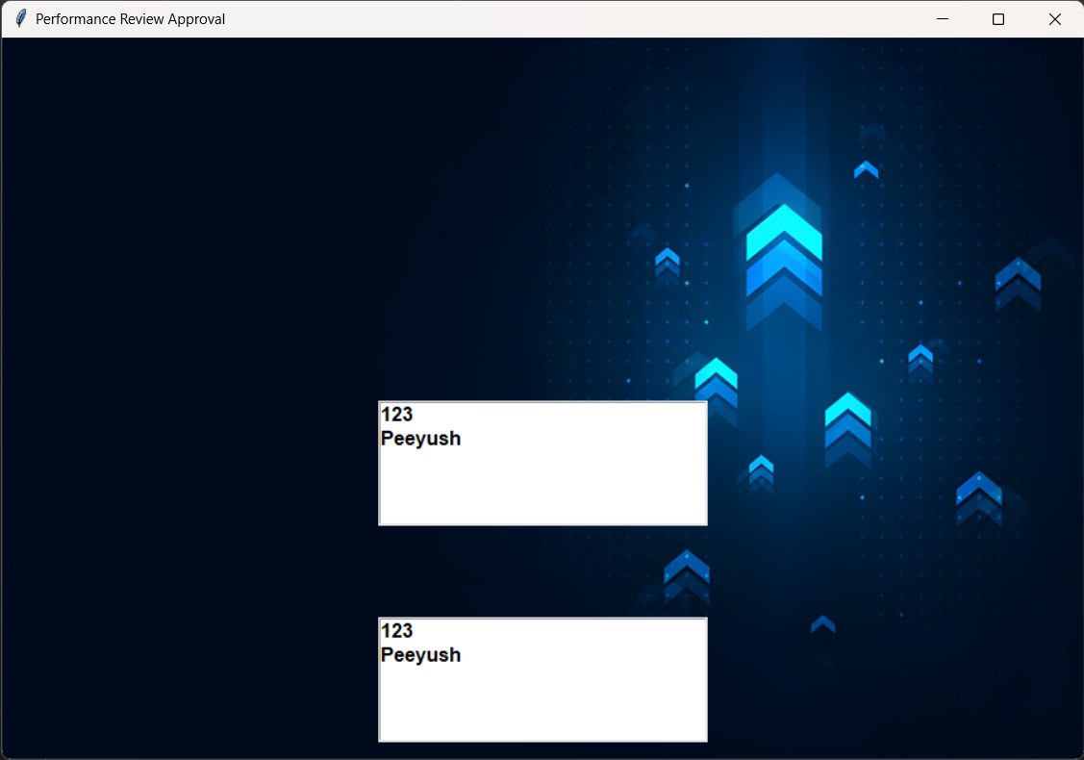

Figure 30

Figure 30: Opens a new window when the approve performance review button is clicked, this displays the list of employees who have filled their quarterly and annual reports separately, clicking each employee’s name will give the information they have filled, that performance review can then be approved or denied by the manager.

31

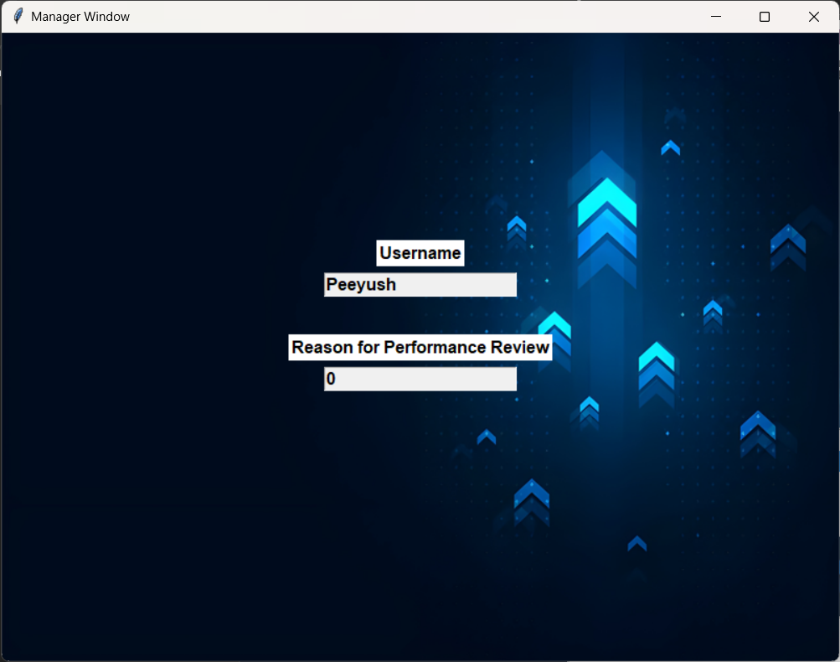

Figure 31

Figure 31: Shows the details of the performance review filled in by the employee along with approve and deny buttons for the performance review.

32

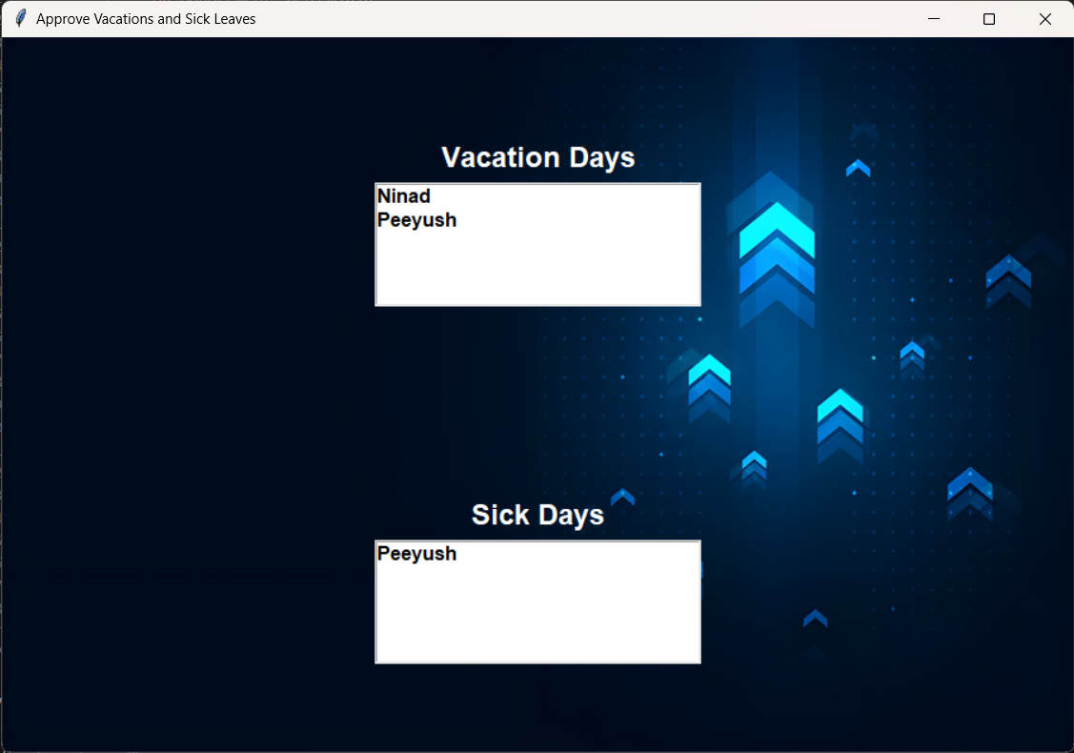

Figure 32

Figure 32: The list of employees whose vacation and sick leave approvals are still pending will be shown in separate list here, the Manager can then click on each user’s name and view the details filled in.

Details for vacations days (figure 33) and sick days (figure 35) are shown separately to reduce confusion for the Manager.

33

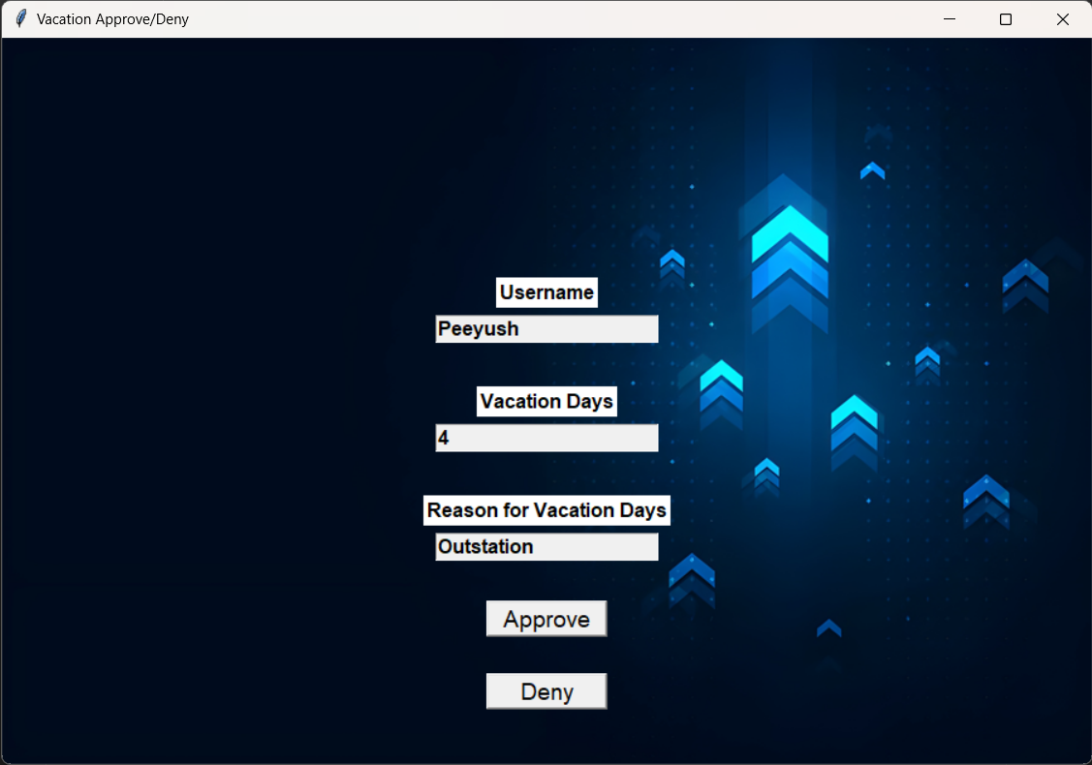

Figure 33

Figure 33: Shows the number of vacation days requested along with buttons to the approve or deny the request by the employee.

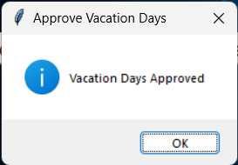

Figure 34

Figure 34: The prompt given to the manager after approval or denial of the request.

34

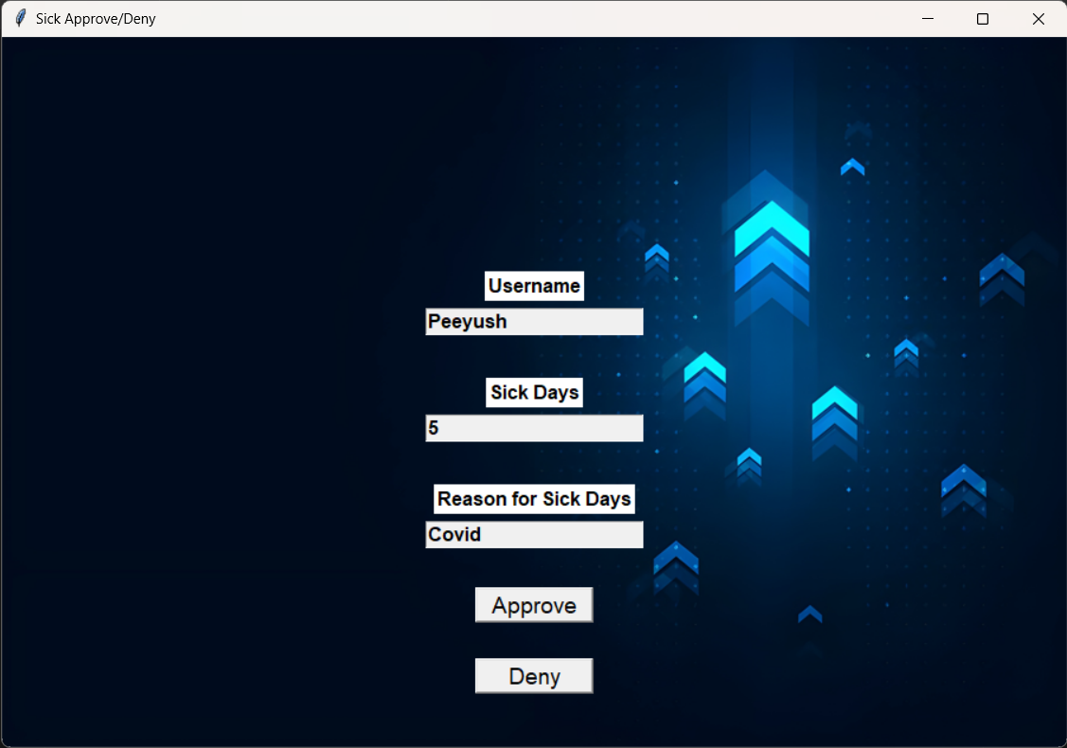

Figure 35

Figure 35: Shows the number of sick days requested along with buttons to the approve or deny the request by the employee.

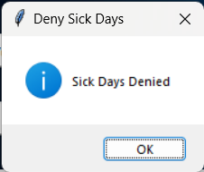

Figure 36

Figure 36: The prompt given to the manager after approval or denial of the request.

35

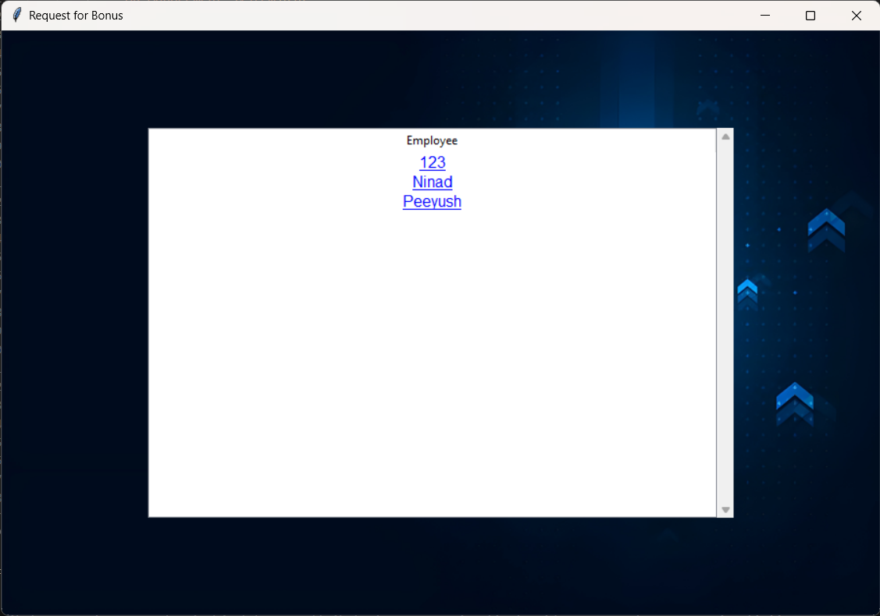

Figure 37

Figure 37: When the Request for bonus button is clicked a new window is created which gives the list for the employees which are clickable, upon clicking that window a new window is further created (figure 38).

36

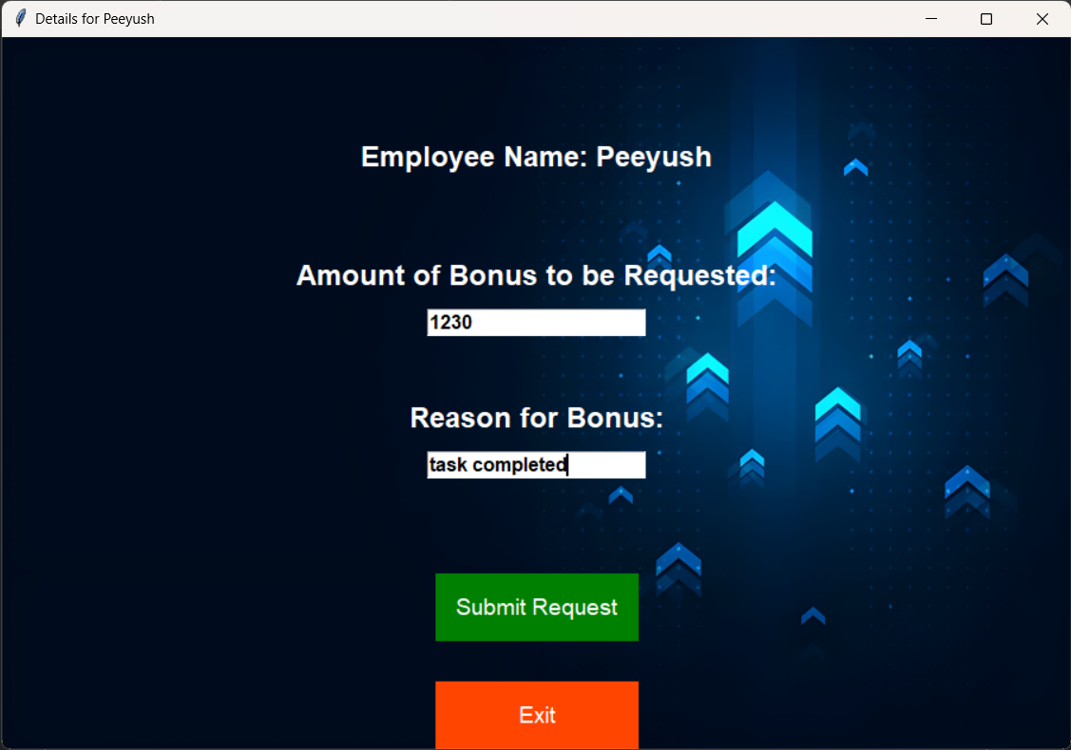

Figure 38

Figure 38: This new window gives the option for the amount of bonus to be requested by the manager for the employee along with the reason for this. There are also two buttons to submit the request or exit from that window.

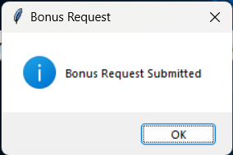

Figure 39

Figure 39: Clicking the submit request button will show this success confirmation and the data will be updated in the DB.

37

Employee Window:

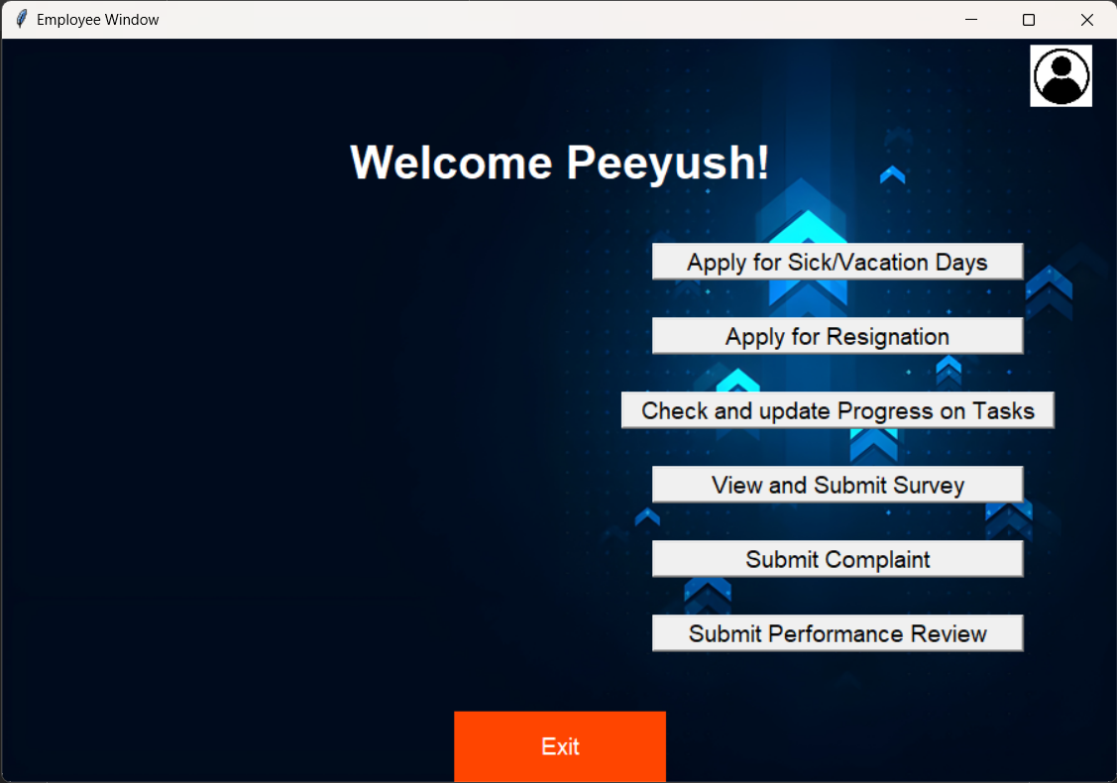

Figure 40

Figure 40: The window shown to the employee role and permission level, it consists of options to Apply for sick/vacation days (figure 41), apply for resignation (figure 44), check and update progress on tasks, view and submit surveys created by the HR, submit complaints of various things and submit their own performance review.

38

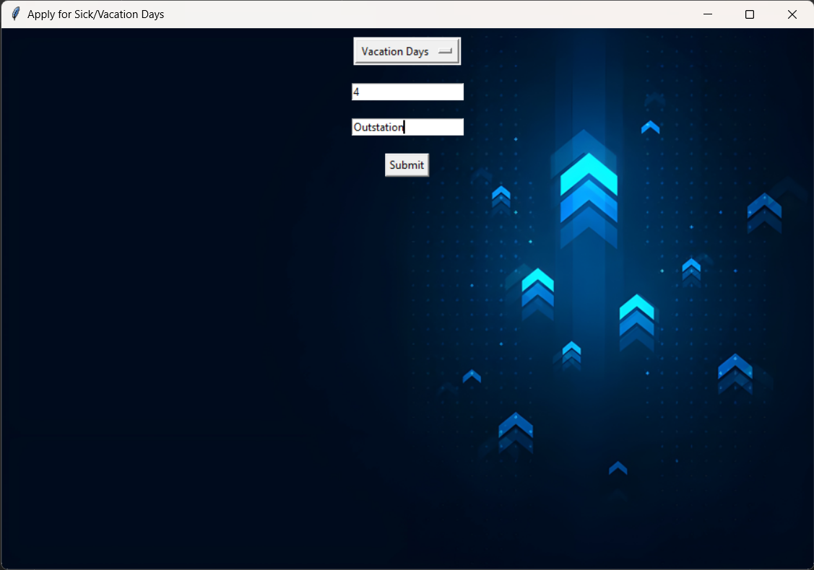

Figure 41

Figure 41: This window is opened when the employee clicks on the Apply for Sick/Vacation days button, it gives the employee the options to choose between the sick(figure 43) and vacation days request along with the number of days to be requested and the reason for the request.

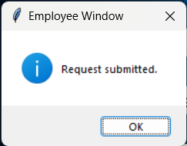

Figure 42

Figure 42: The dialog box shown when the employee submits the request and the data has been pushed to the DB.

39

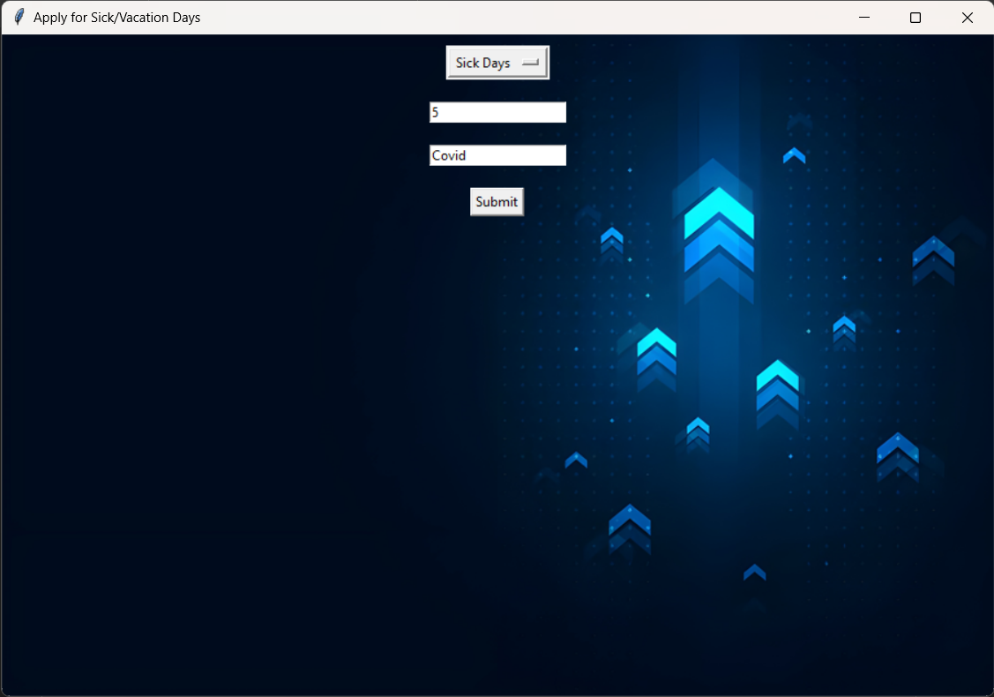

Figure 43

40

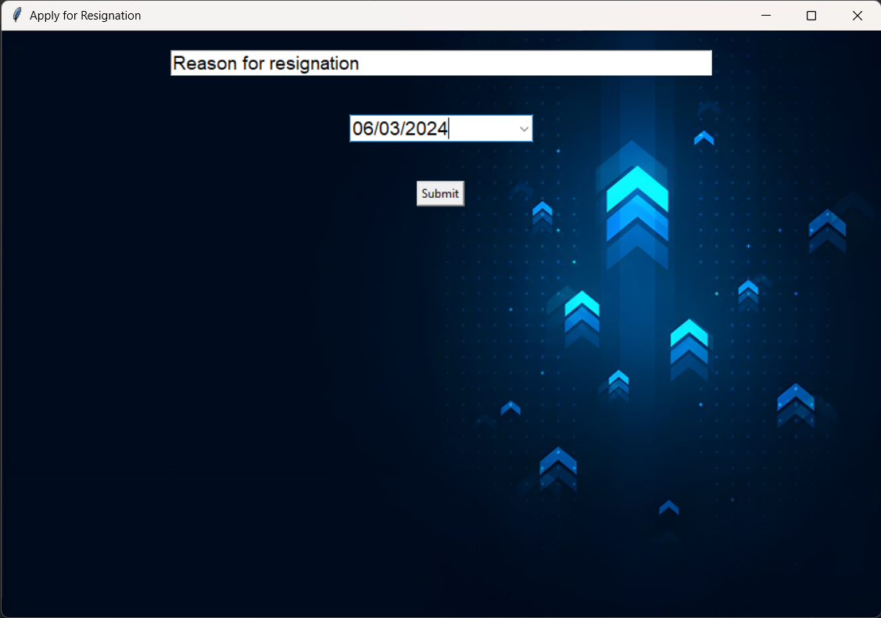

Figure 44

Figure 44- The window shown when the user clicks on the apple for resignation button, which ask the user for the to apply for resignation (minimum 2 weeks notice) along with the reason for the resignation and a submit button to submit the request.

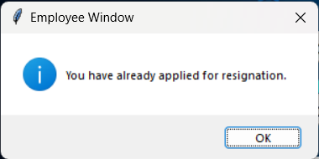

Figure 45

Figure 45- The dialog box shown when the user has applied for the Resignation by clicking on the submit button.

41

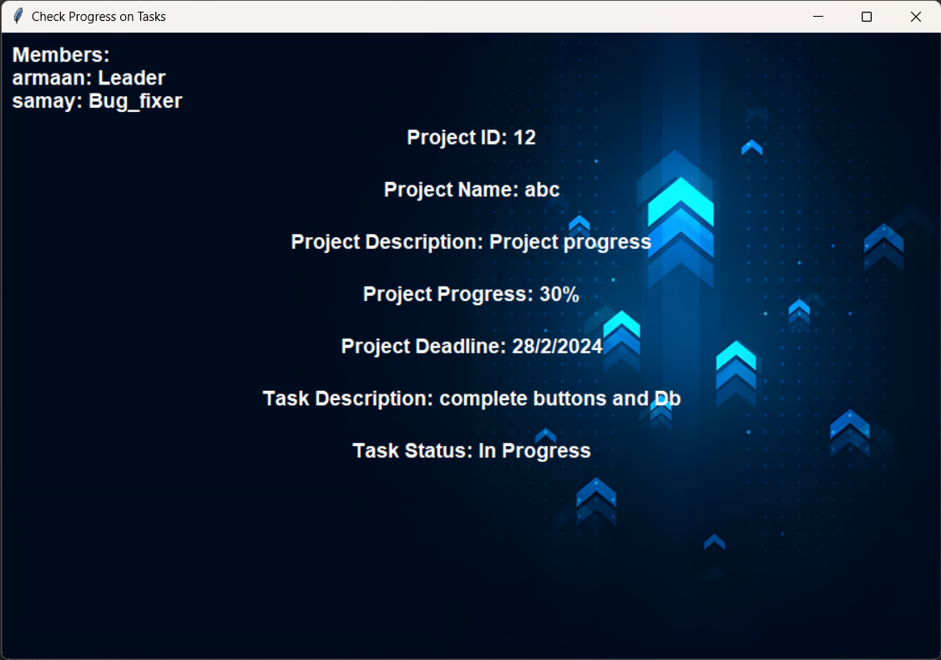

Figure 46

Figure 46- The window shown when the employee clicks on the check progress on task button, it also gives the option to update the progress and mark the task as completed.

42

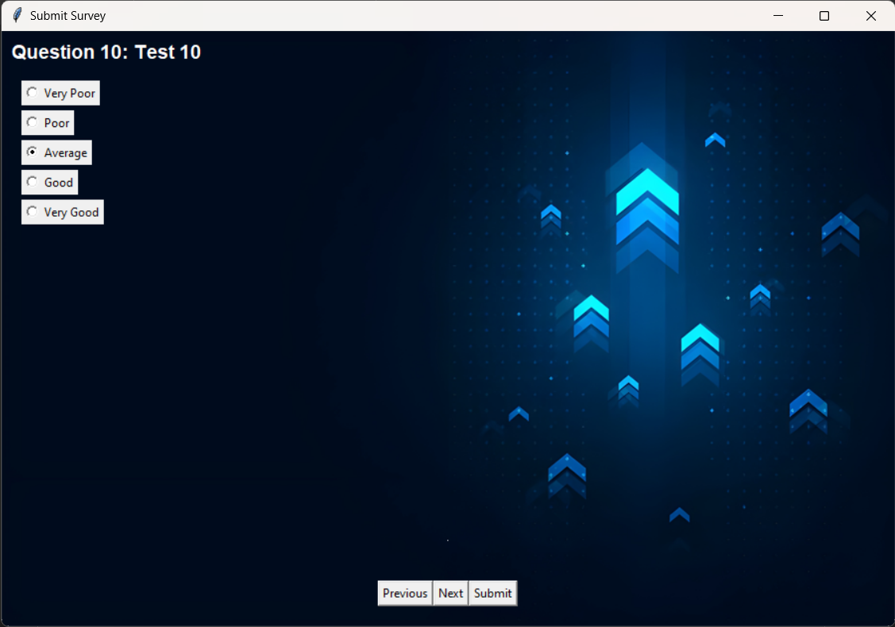

Figure 47

Figure 47- The window shown when the user clicks on the submit survey button to fill the survey set by the HR for the employees. The questions are displayed along with the question number and the radio buttons for the options, at the bottom of the window there are 3 more buttons for previous, next and submit.

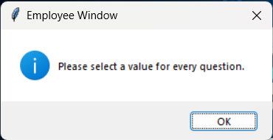

Figure 48

Figure 48- When the user submits the survey, the Survey submitted window is shown and the data is then stored in the DB.

43

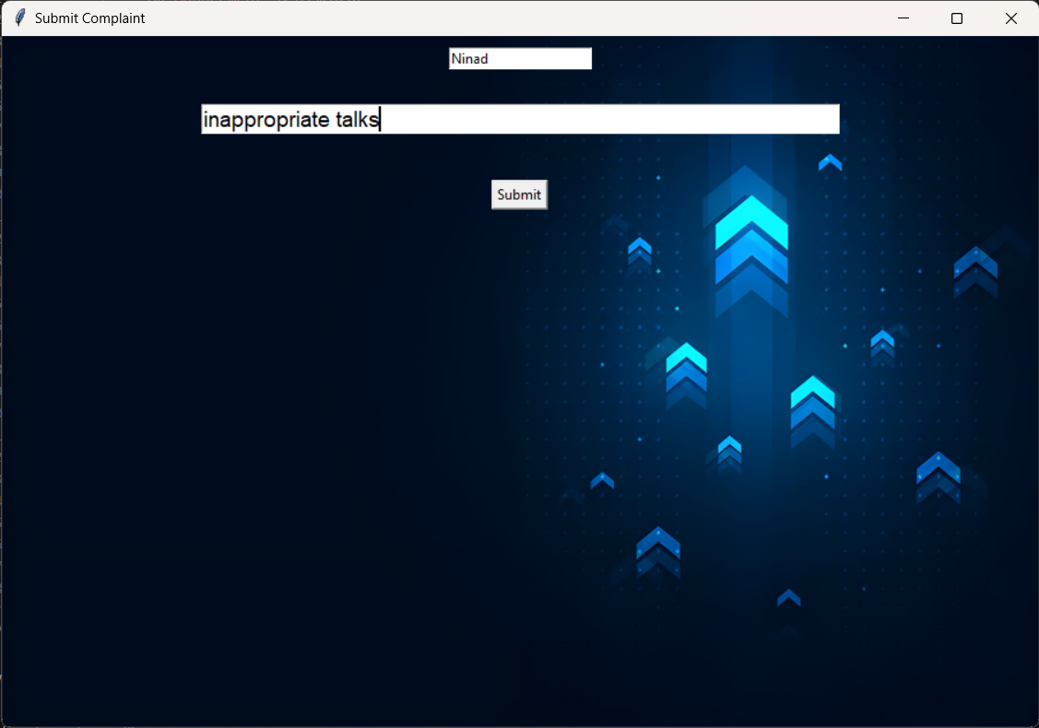

Figure 49

Figure 49- When an employee clicks on the submit complaint button this window is created which gives 2 input boxes for the name of the employee along with the reason for the complaint, after the two input boxes there is a submit button.

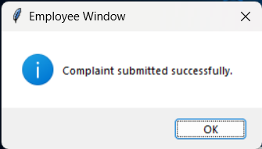

Figure 50

Figure 50- When the submit button is pressed it shows a success dialog box and sends the data to be stored in the DB.

44

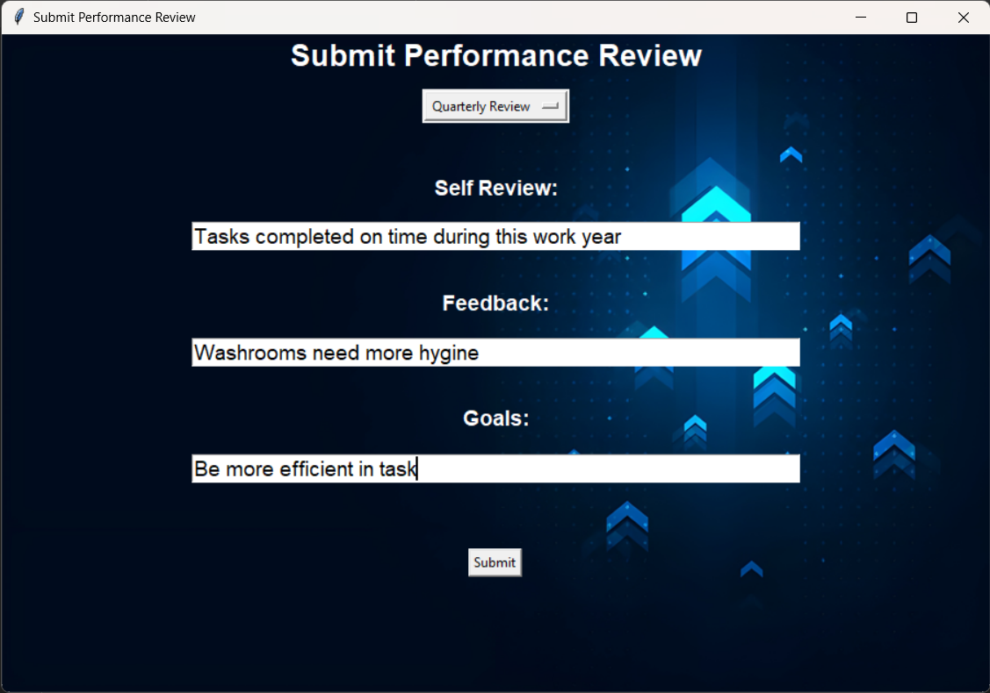

Figure 51

Figure 51- When the Submit performance review button is clicked this window is shown to the user which gives the option to select from quarterly review and annual review, along with 3 input boxes for their self review, feedback for the company and future self goals, below the input boxes is a submit button.

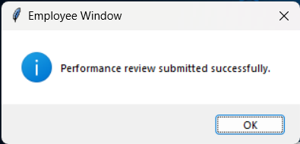

Figure 52

Figure 52- When the submit button is clicked the success dialog is shown and the data is stored in the DB.

45

Profile Window:

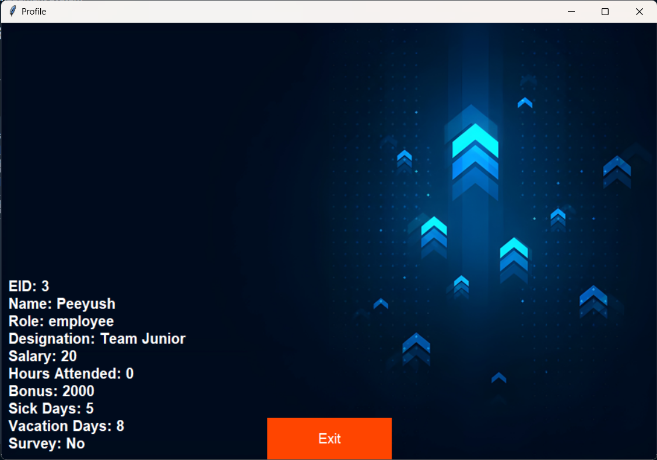

Figure 53

Figure 53- This is a common window shown for HR/Manager/Employee when the profile button is clicked at the top right of the main window after putting the login details and successful login.

46

3.6 Conclusion and Future Scope :-

Conclusion:-

The conclusion for an HR management system can highlight its significance in streamlining organizational processes, enhancing employee engagement, and optimizing HR functionalities. It underscores the system's role in promoting efficiency, transparency, and compliance within the organization. Additionally, it may emphasize the importance of ongoing evaluation, feedback mechanisms, and adaptation to evolving HR needs and technological advancements. In conclusion, implementing and maintaining an effective HR management system can significantly contribute to the overall success and sustainability of the organization in today's dynamic and competitive business environment.

Future Scope:-

The future scope of HR management systems is promising and likely to evolve in several key areas:

1. User Authentication and Authorization: Implement more robust user authentication mechanisms such as two-factor authentication (2FA) or OAuth for enhanced security. Also, refine the authorization system to ensure that users only have access to the features and data relevant to their role.
2. User Interface Enhancements: Improve the user interface with modern design principles, responsiveness for different screen sizes, and accessibility features to cater to a wider range of users.
3. Advanced Reporting and Analytics: Integrate data visualization tools to generate comprehensive reports and analytics on employee performance, HR metrics, and managerial insights. This can help in making data-driven decisions and identifying areas for improvement.
4. Integration with External Systems: Enable integration with other enterprise systems such as payroll management, CRM, or project management tools to streamline data exchange and improve workflow efficiency.
5. Mobile Application: Develop a mobile application version of the platform to enable employees and managers to access key features on the go, such as submitting performance reviews, viewing schedules, or checking HR updates.

47

4.REFERENCE

1. Chatgpt: Helped in bug fixing along with some help for developing new ideas.
2. Stackoverflow: Used in solving bugs and getting methods to solve certain issues.
3. Youtube: Helped in getting new ideas for the project and ways to implement them.
4. Geekforgeeks: Wording for creating documentation and ppt
5. Google: Helped in info for parts of ppt and documentation along with random bug fixes.

48